1. **Daily notes**
2. **Interview questions and answers**
3. **Difference**

**Programs**

1. Odd number from 300 to 500(for, while, do while)

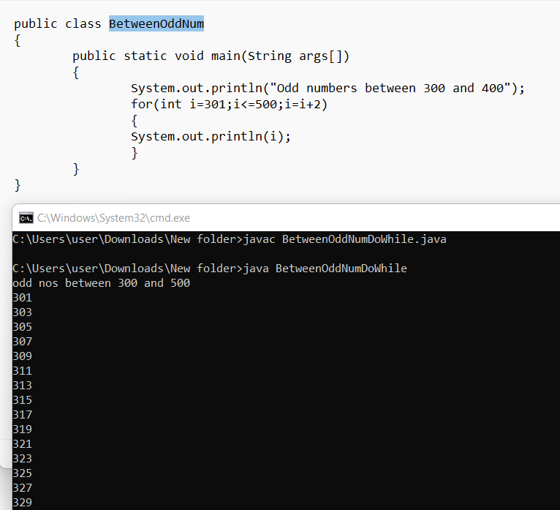

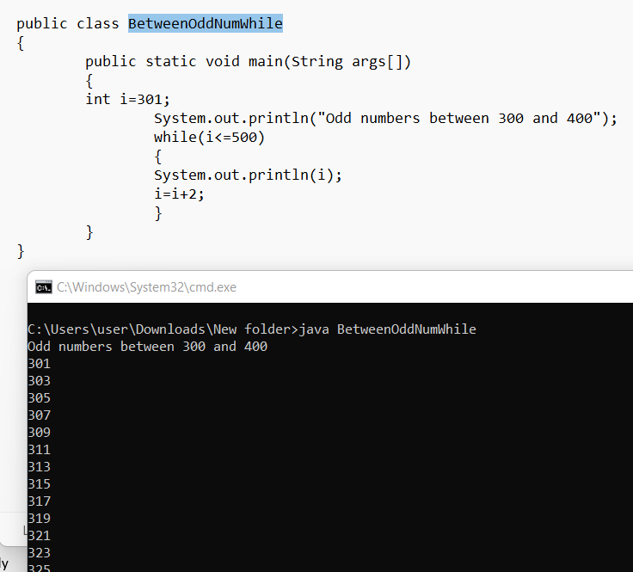

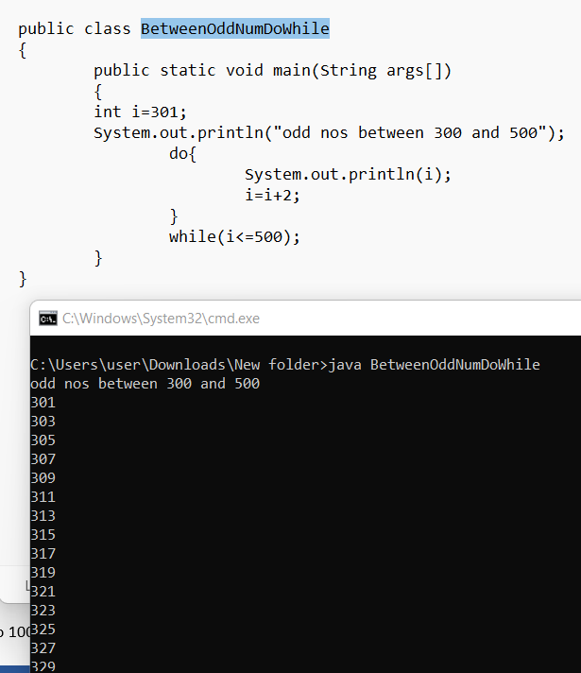

1. Even number from 500 to 600(for, while, do while)

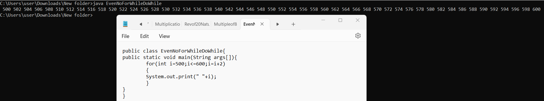

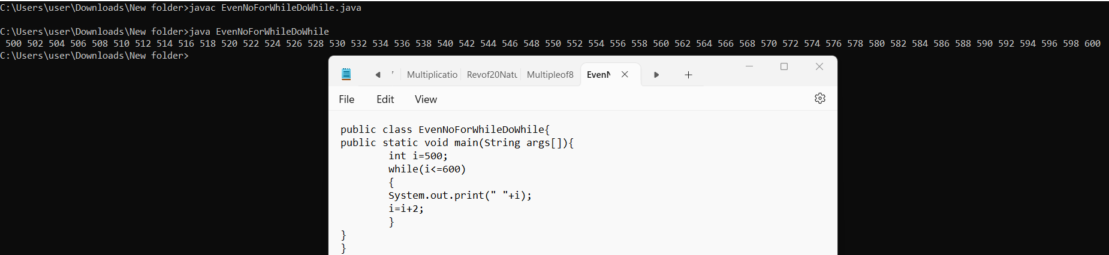

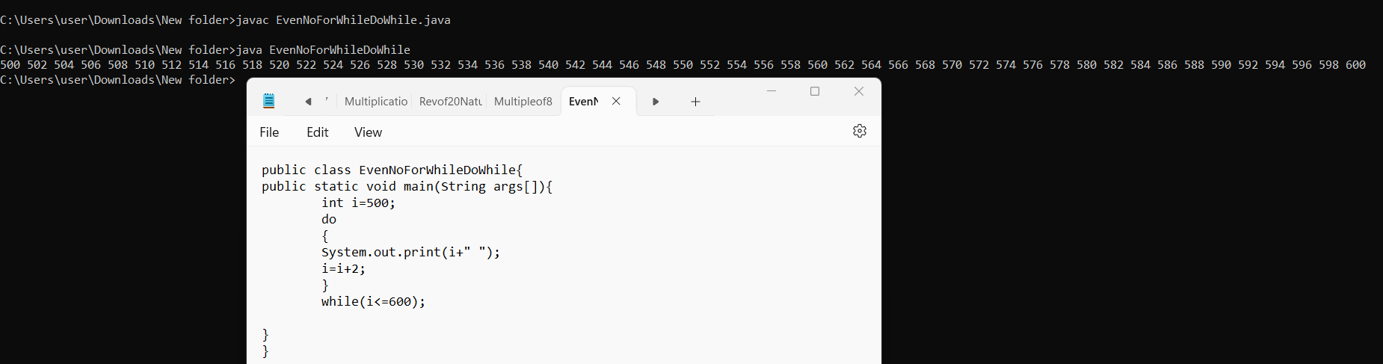

1. Sum of first 20 natural numbers (for, while, do while)

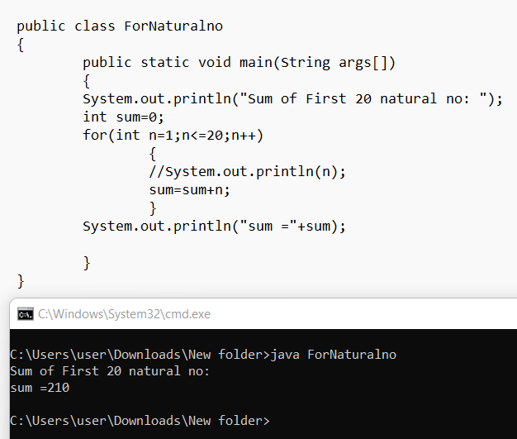

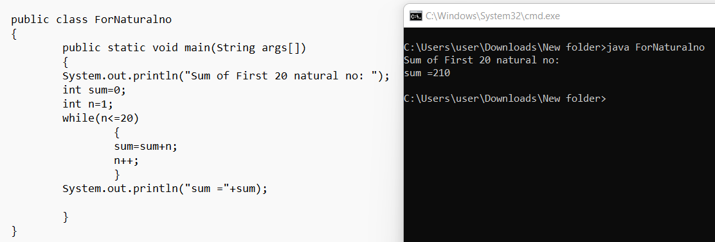

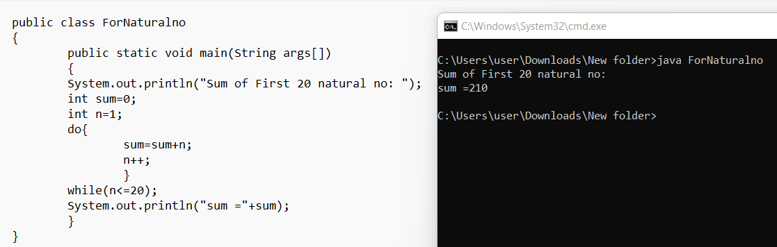

1. Write a program to print multiplication of 5 from 20 to 150 (for, while, do while)

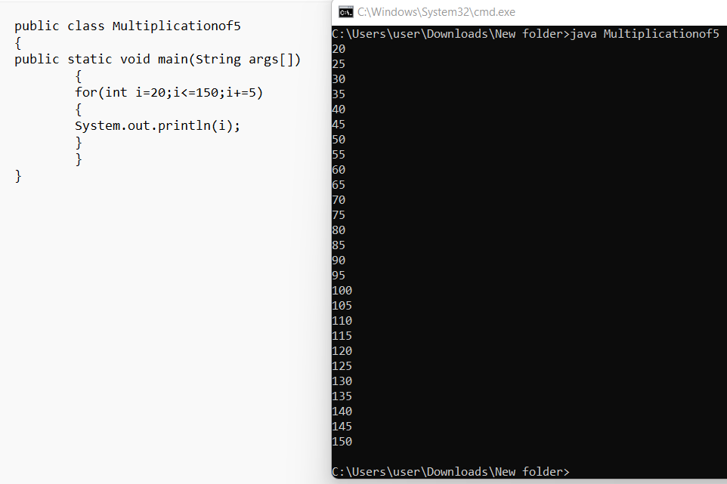

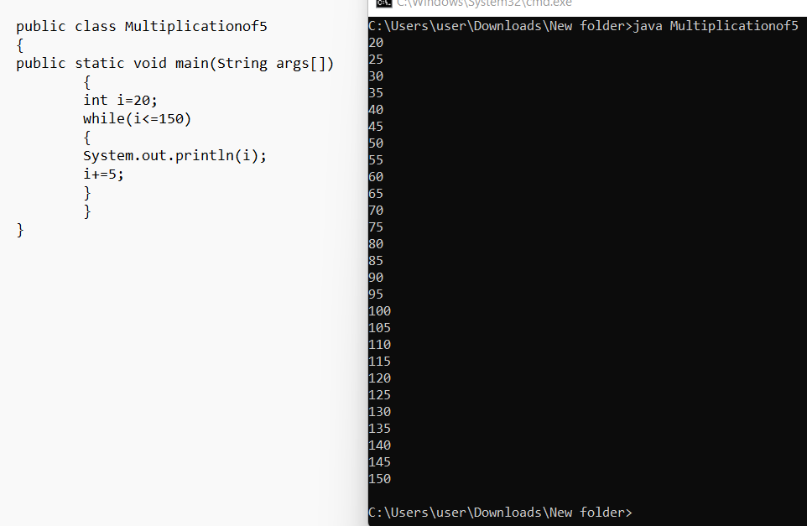

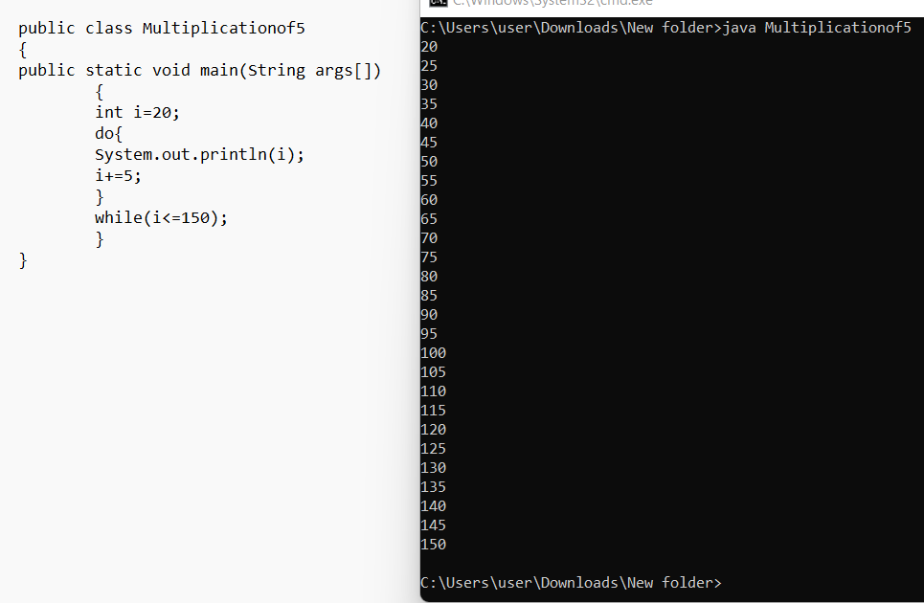

1. Reverse of first 20 natural number(20 to 0)

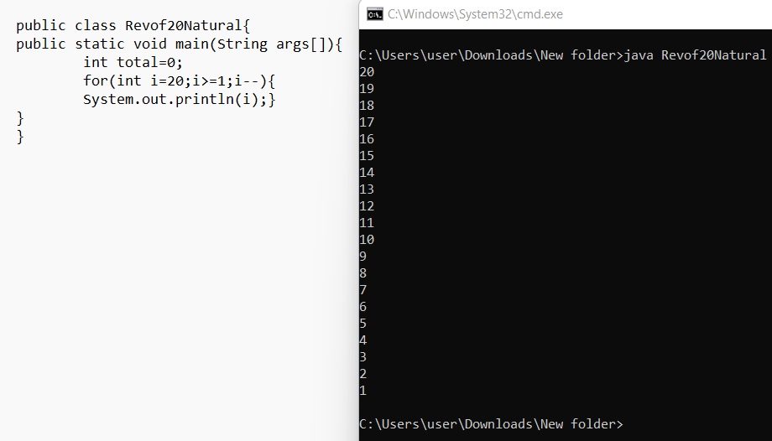

1. Multiple of 7 from 100 to 300

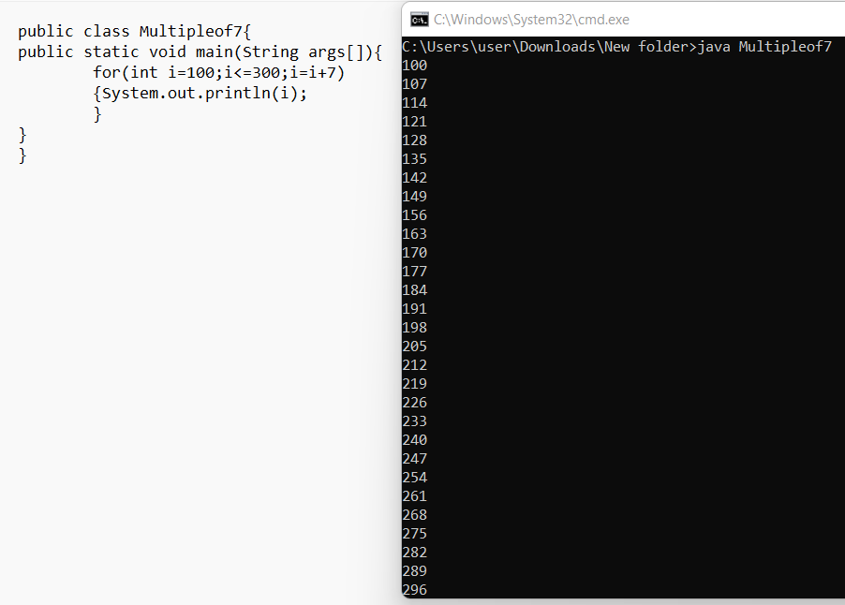

1. In reverse order multiple of 8 from 300 to 100.

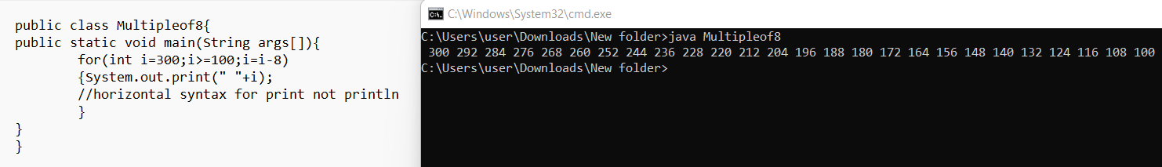

1. Sum of odd number from 1 to 100 only

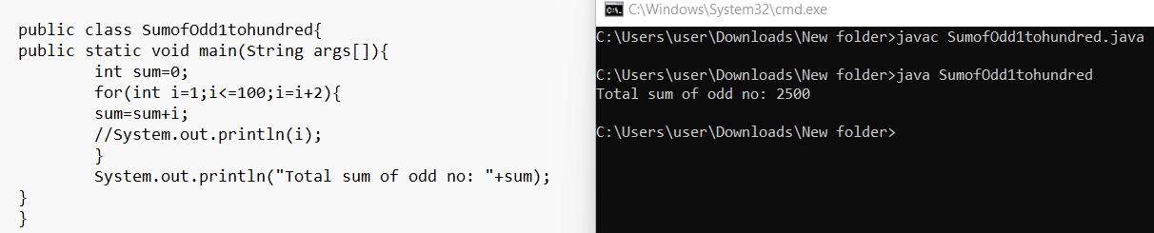

1. Sum of even number from 100 to 200 only

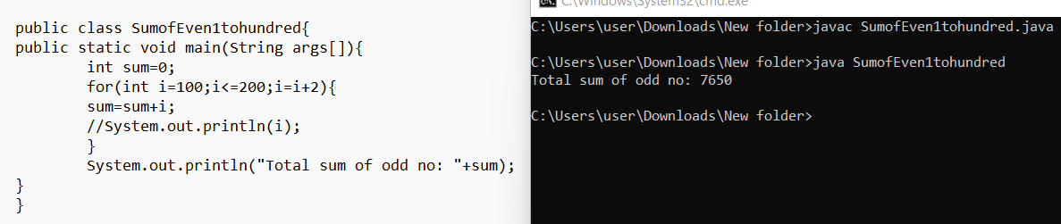

1. Multiplication table of 9 eg: in output 1*9=9 upto 10*9=90 each in single line.

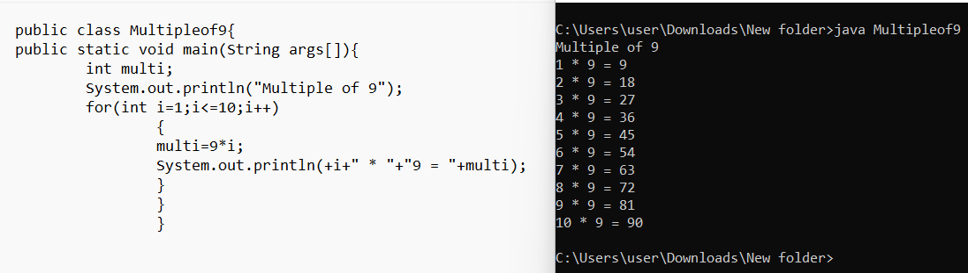

**Triangle Patterns**

1. **Right triangle**

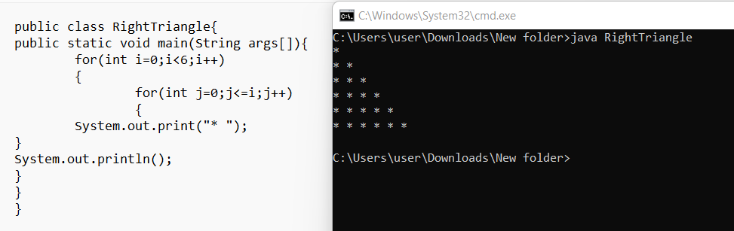

1. **Left Triangle.**